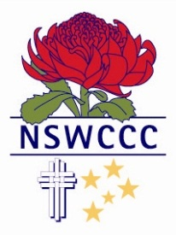

NSW COMBINED CATHOLIC COLLEGES SPORTS ASSOCIATION

JAKE WIGHAM
Blue Award
2015
Hockey
St Edward’s College Gosford

Jake has been a member of the New South Wales Combined Catholic Colleges Open Hockey team for the past two years. He has displayed consistently good form in hockey and his performances at the Open Tri Series led the way for Jake to be named in the New South Wales All Schools Open Merit Team in 2014 and 2015.
Jakes is dedicated to his sport and along with his leadership and great sportsmanship he has been a wonderful example and inspiration to his peers.
In 2015 Jake was a member of the School sport Australian team that toured Europe. The team competed in the European under 16 Tournament. Jake was an integral part of the Australian Boys’ team that won the European Junior Hockey Tournament.
Jake is dedicated to his sport and along with his leadership and great sportsmanship he has been a wonderful example and inspiration to his peers.
He is an active participant and leader in all sporting activities at his school. Jake has also represented his school and Diocesan at Cross Country

